Design 11
Communication Plan
New Germany Rural High School
Mrs. Johnston

Welcome to Design 11! Design 11 provides students with the opportunity to understand and apply the design process, responding to, and changing the world around us. This course offers students skills and values that they can apply to a range of learning challenges and career opportunities.

Units for study and value

Design Fundamentals (10%)
Students will be expected to apply the elements and principles of design to a range of problems in a variety of contexts.

Design in the Built Environment (20%)
Students will use their understanding of issues, principles, processes, and technology to solve design problems in the built environment.

Communications Design (35%)
Students will be expected to use a variety of forms to design communications for a range of purposes.

Product Design (20%)
Students will use their understanding of issues, principles, processes, and technology to design products used in their environment.

Design Project (15%)
Students will be expected, independently or as members of a design team, to conduct an investigation or create a product, communication or environment.

Assessment:

Assessment is the process of gathering, from a variety of sources, information that accurately reflects how well a student is achieving the learning outcomes in a subject or course.

a) formative assessment is to show growth over time, determine student needs, plan next steps in instruction, and provide students with descriptive feedback.

b) summative assessment is to determine the extent to which learning has occurred
for students.

Types of assessment used:

In class assignments, homework, projects, presentations, quizzes and tests.

Student progress will be communicated through PowerSchool, phone calls, emails, parent teacher meetings and report cards.

If you have any questions, please contact me at meljohn@gnspes.ca, or 902 644-5000. Information regarding course objectives, resources, assignments, due dates, quizzes, etc. can be found on my website at http://meljohn@weebly.com.

Ready to Learn:

- Students are expected to attend class regularly, on time, and prepared to learn. If you are having difficulty meeting these expectations, please speak with your teacher, guidance counsellor, or administration for assistance.

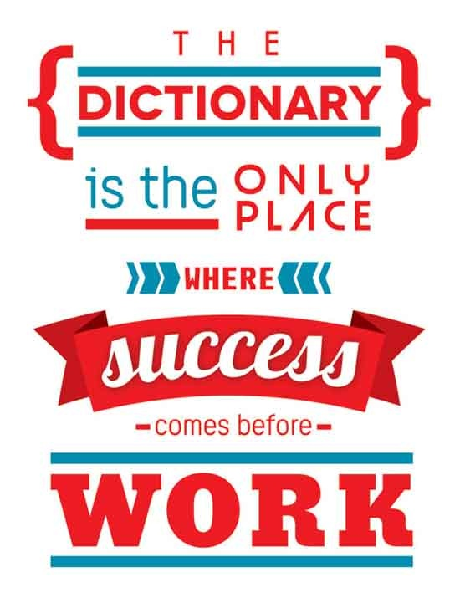
- Respect for yourself, your peers, and staff is another essential component of being ready to learn. The school will follow the provincial code of conduct in addressing behavioural concerns in the classroom, and will provide supports for students who are facing challenges preventing them from being successful in this aspect of school life.

